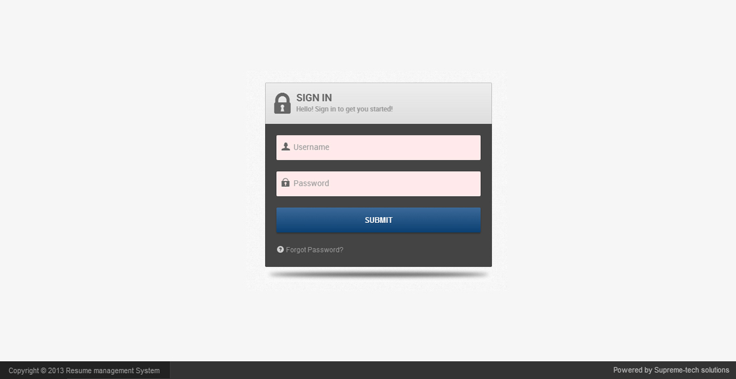

Resume Management System Login Form For User and admin

**Administrator Functionality:**

After Successful login for Admin the dashboard will look as below:

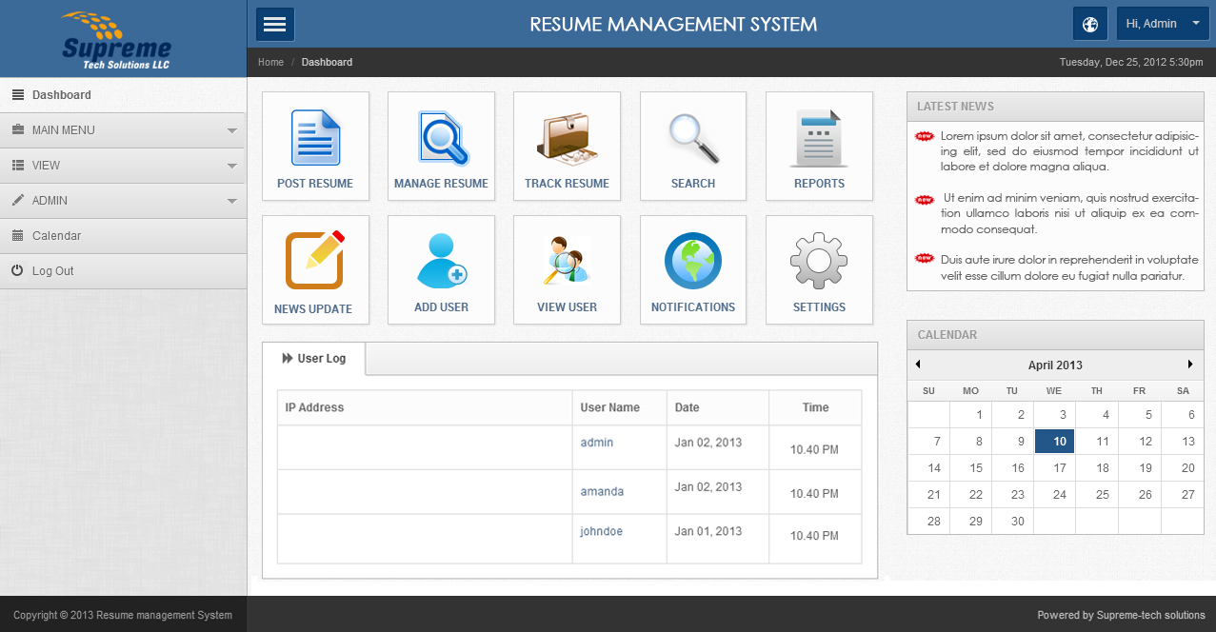

Dashboard contains left side menu ,user log details, calendar and Latest News (Admin can update the news dynamically ).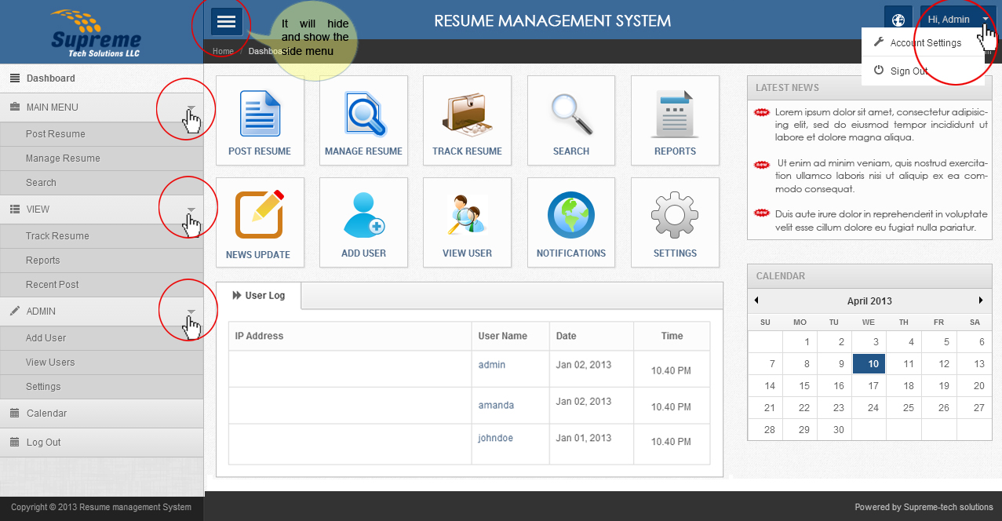

Admin only have the privilege to create new user and can view all the user’s details .

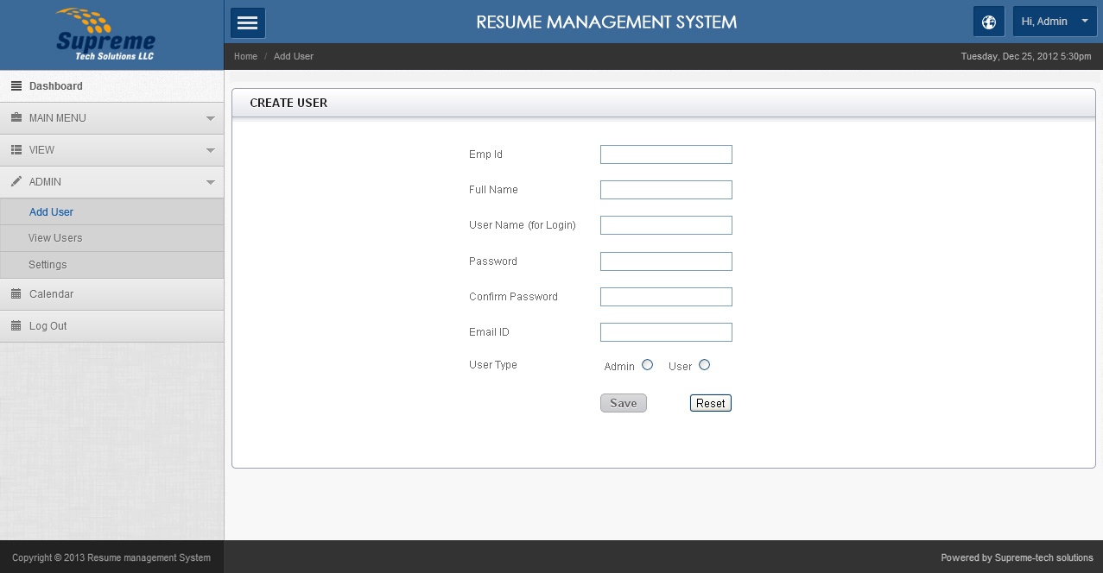

There are two user types namely admin and user. Admin have all rights to manage the posted data ,filter and can edit data .Admin have (DDL and DML )Functionality

**View Users Detail By Only Admin**

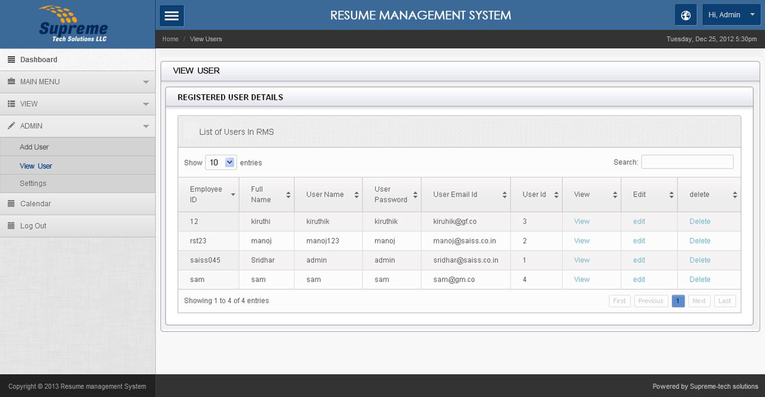

Admin can edit,view,delete the user accounts.

**Admin Can also Post the Resume.**

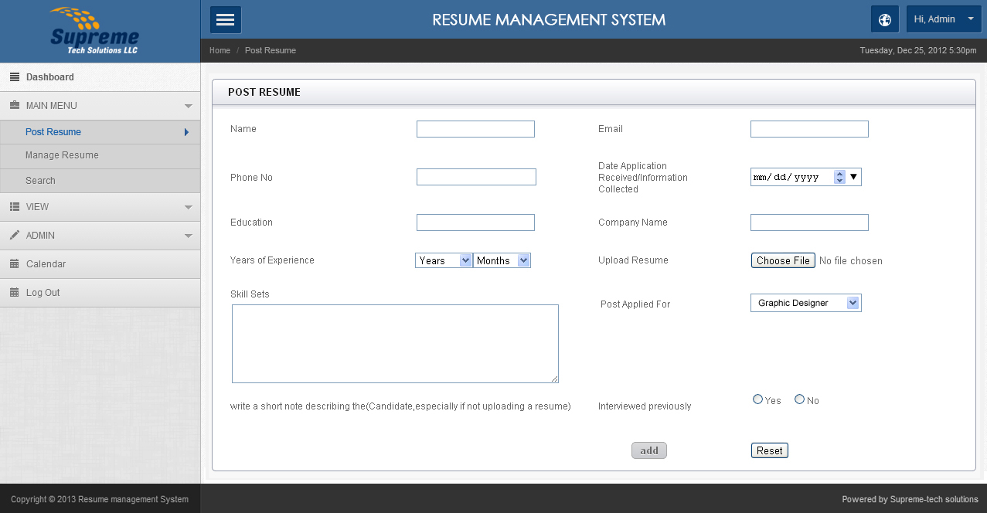

**Mange Resume**

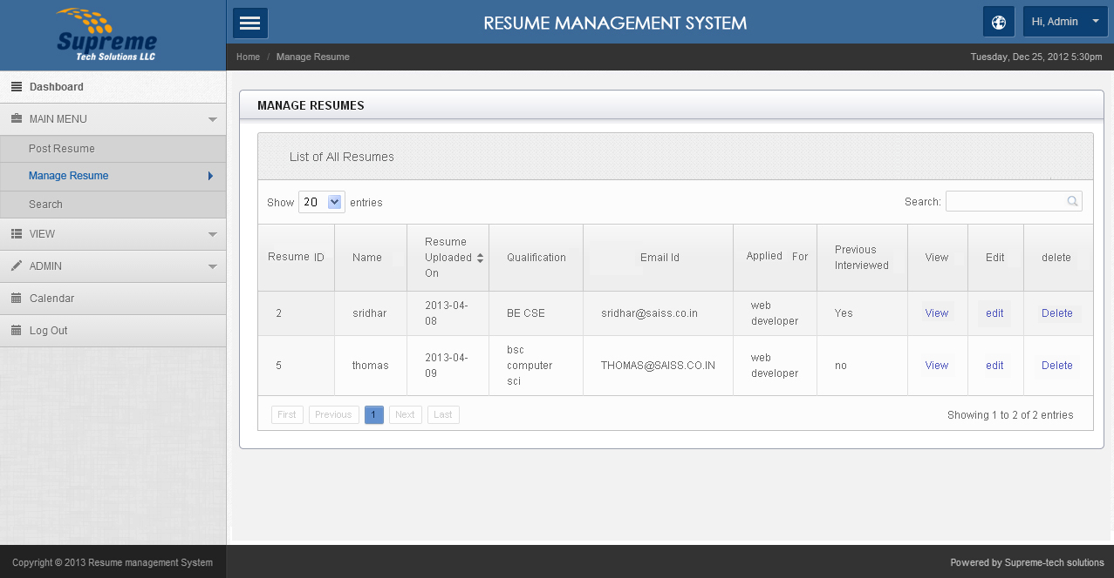

Admin manage the resume can edit, view, delete functionality. Admin only have the privilege to access these pages.

Admin can search the particular or any data through by enter value in search field.

**Track Resume**

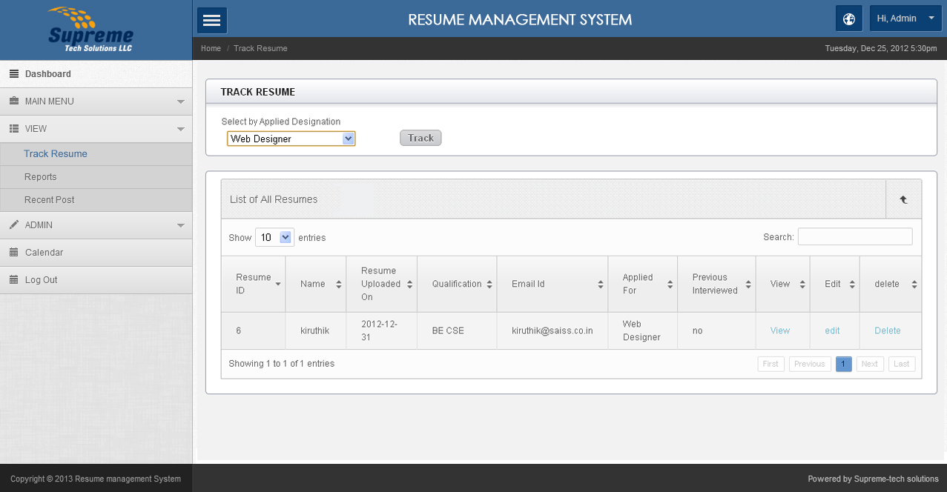

Admin can track the resume by Applied Designation and track the particular data through search box.

**Search**

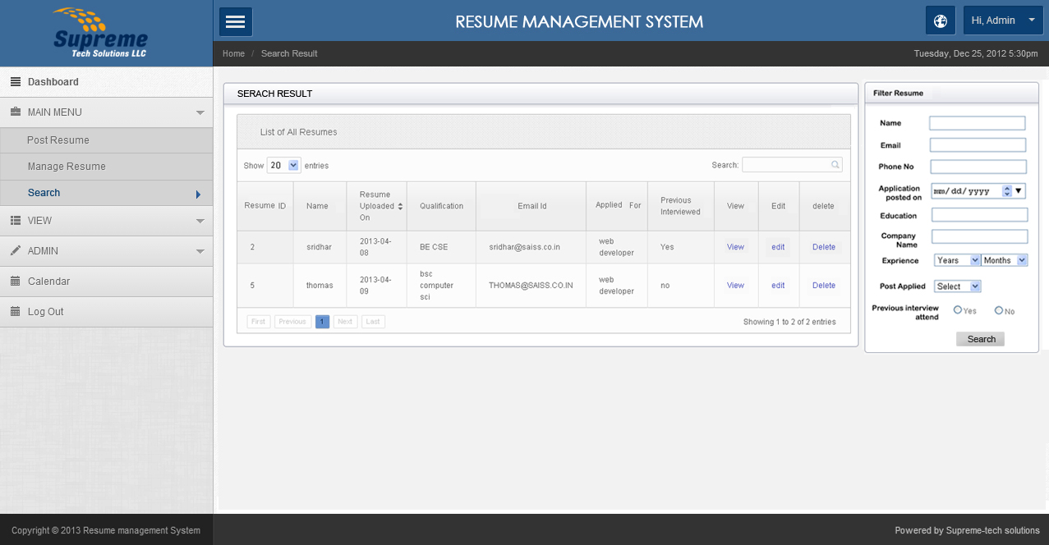

Admin can filter resume by 9 categories, which are available in side box (Filter Resume) .

**View Particular Resume**

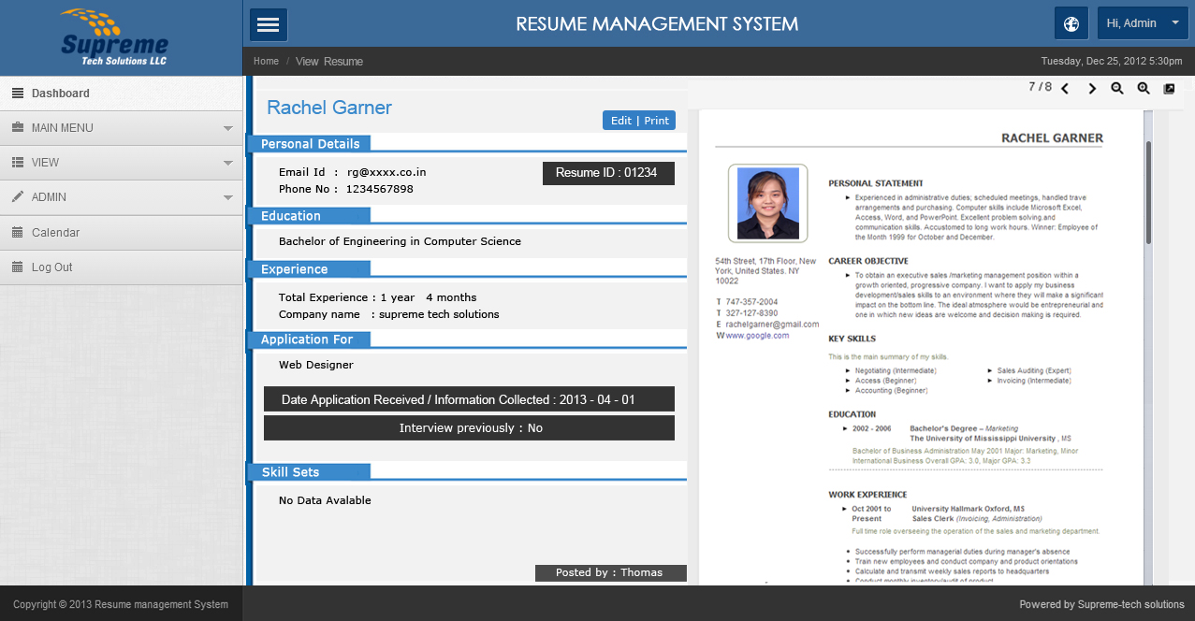

Admin can able to view particular posted resume details

**Edit Particular Resume**

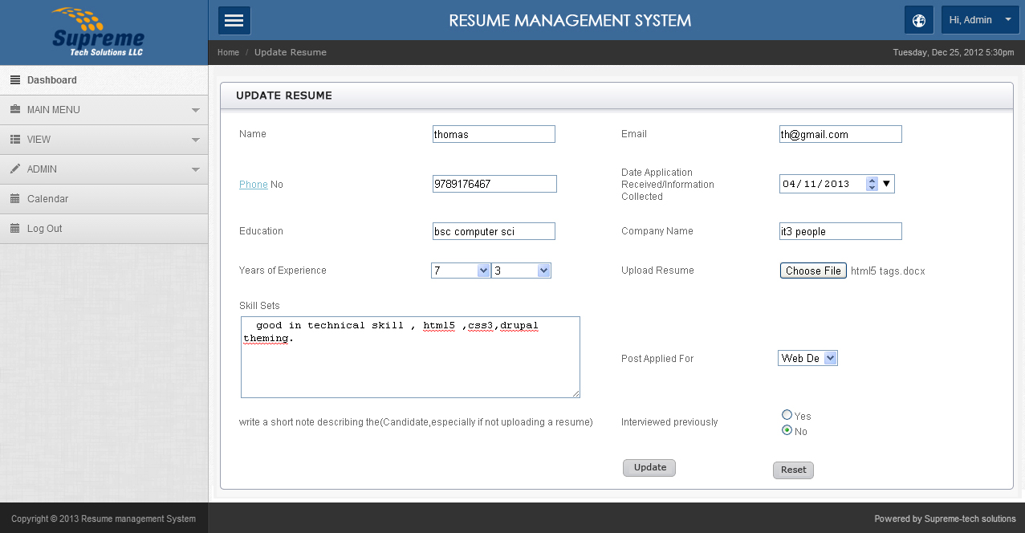

Admin only able to update the posted resume details

**Reports**

In reports page admin can download entire database which are uploaded by the user.

Admin can download user details in a document and excel formats.

Data availability in database are shown in graph.

Note* : report page, post notification page will be updated to you by tomorrow­ .

--------------------------------------- ---------Admin Functionality Ends -------------------------------------------------------

**User Functionality**

After Successful login for User the dashboard will look as below:

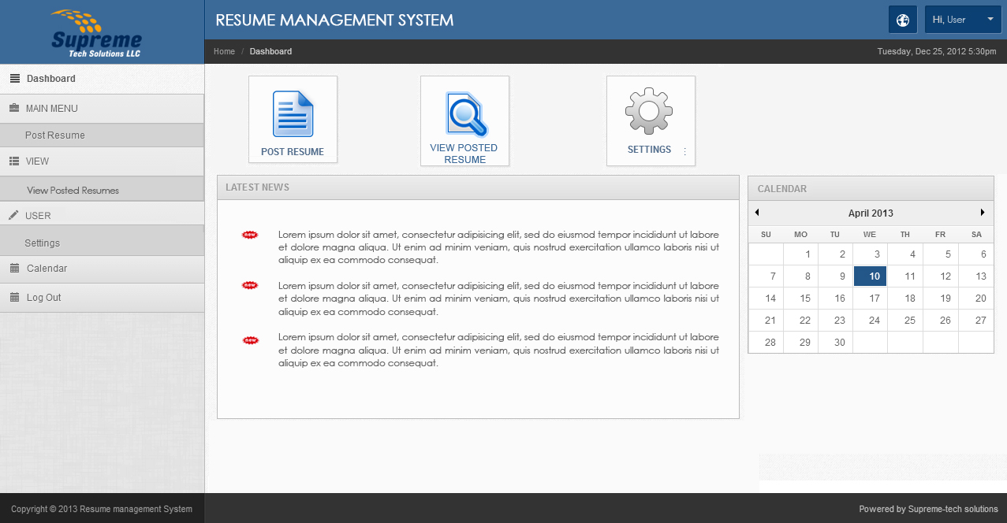

User can able to Post the details from resumes and can view which they posted in table but they can’t view the fully.

**Posted Resumes**

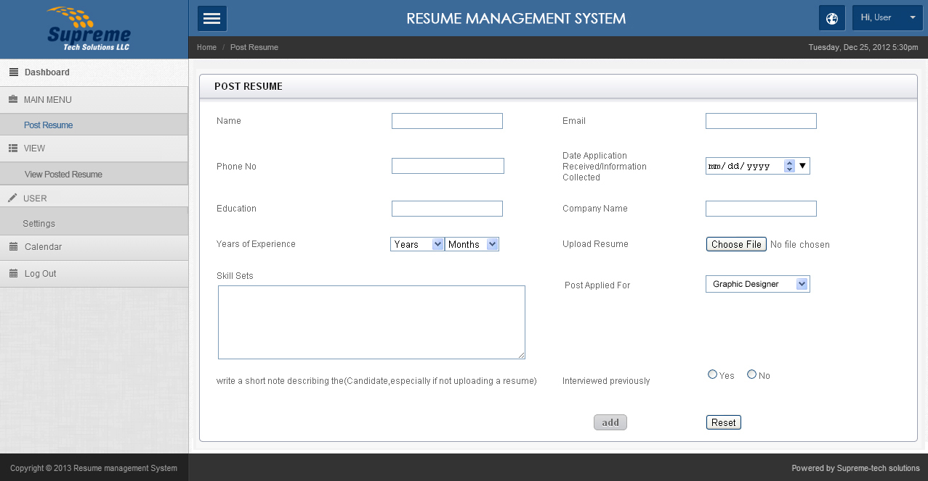

View Posted Resume Page

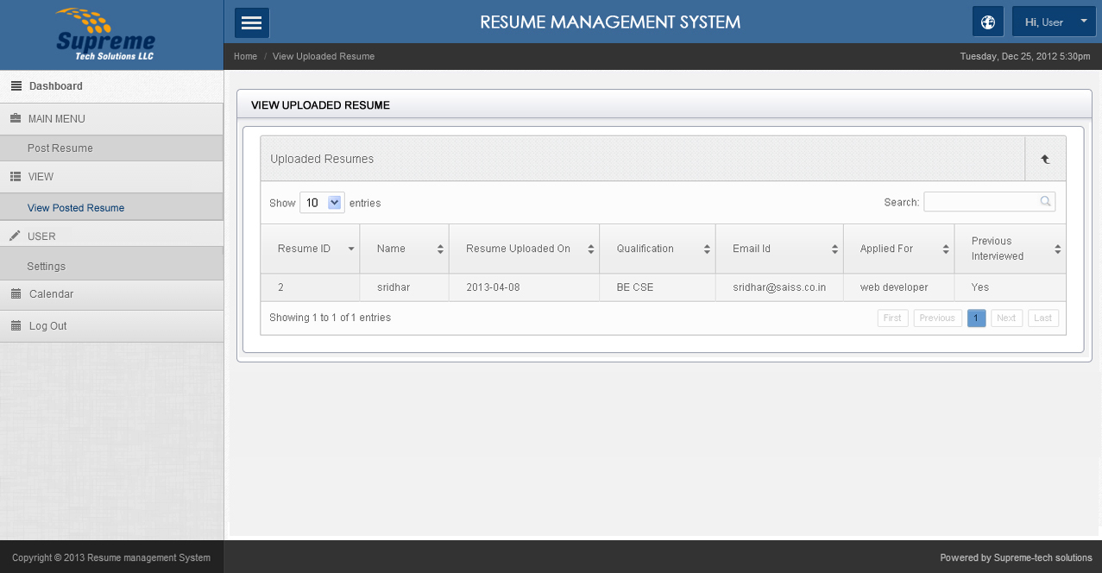

User’s unable to delete or view the full data which they posted.

**Account Setting**

User can edit their profile password.

-------------------------------------------------User Functionality Ends -------------------------------------------------------